Suresh Games

Presents “mr. Mini” the endless runner game

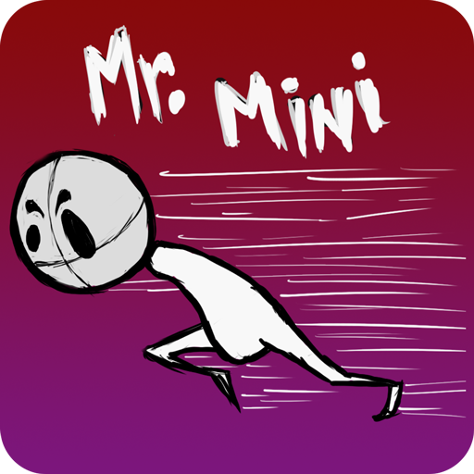

Revision: 0.0.1

GDD Written by: Suresh Rao

Overview

Theme / Setting / Genre

Core Gameplay Mechanics Brief

Targeted platforms

Monetization model (Brief/Document)

Project Scope

Influences (Brief)

- <Influence #1>

- <Influence #2>

- <Influence #3>

- <Influence #4>

The elevator Pitch

Project Description (Brief):

Project Description (Detailed)

What sets this project apart?

Core Gameplay Mechanics (Detailed)

- <Core Gameplay Mechanic #1>

- <Core Gameplay Mechanic #2>

- <Core Gameplay Mechanic #3>

- <Core Gameplay Mechanic #4>

Story and Gameplay

Story (Brief)

Story (Detailed)

Gameplay (Brief)

Gameplay (Detailed)

Assets Needed

- 2D

- 3D

- Sound

- Code

- Animation

Schedule

- <Object #1>

- <Object #2>

- <Object #3>

- <Object #4>

# Overview

## Theme / Setting / Genre

- <Insert Theme here>

## Core Gameplay Mechanics Brief

- <Gameplay Mechanic #1>

- <Gameplay Mechanic #2>

- <Gameplay Mechanic #3>

- <Gameplay Mechanic #4>

## Targeted platforms

- WindowsPC

## Project Scope

- <Game Time Scale>

- Cost? (How much will it cost?)

- Time Scale (How long will it take to make this game?)

- <Team Size>

- <Core Team>

- Team Member name?

- What does he/she do?

- <Cost to employ them full time or part time>

- etc.

(List as many core team members as you need to)

- <Marketing Team>

- Team Member name?

- What does he/she do?

- <Cost to employ them full time or part time>

- Etc.

(List as many marketing team members as you need to)

- <Licenses / Hardware / Other Costs>

- <Total Costs with breakdown>

## Influences (Brief)

### - <Influence #1>

- <Medium> (Television, Games, Literature, Movies, etc.)

- /Explain why this is an influence in 1 Paragraph or less/

### - <Influence #2>

- <Medium> (Television, Games, Literature, Movies, etc.)

- /Explain Why in 1 Paragraph or less/

- /Explain why this is an influence in 1 Paragraph or less/

### - <Influence #3>

- <Medium> (Television, Games, Literature, Movies, etc.)

- /Explain why this is an influence in 1 Paragraph or less/

### - <Influence #4>

- <Medium> (Television, Games, Literature, Movies, etc.)

- /Explain Why in 1 Paragraph or less/

- /Explain why this is an influence in 1 Paragraph or less/

## The elevator Pitch

<A one sentence pitch for your game.>

Pretend that your were pitching your game to a executive going to the elevator. You have less than 60 Seconds.

## Project Description (Brief):

<Two Paragraphs at least>

<No more than three paragraphs>

## Project Description (Detailed)

<Four Paragraphs or more If needs be>

<No more than six paragraphs>

# What sets this project apart?

- <Reason #1>

- <Reason #2>

- <Reason #3>

- <Reason #4>

- <etc.>

## Core Gameplay Mechanics (Detailed)

### - <Core Gameplay Mechanic #1>

- <Details>

/Describe in 2 Paragraphs or less/

- <How it works>

/Describe in 2 Paragraphs or less/

### - <Core Gameplay Mechanic #2>

- <Details>

/Describe in 2 Paragraphs or less/

- <How it works>

/Describe in 2 Paragraphs or less/

### - <Core Gameplay Mechanic #3>

- <Details>

/Describe in 2 Paragraphs or less/

- <How it works>

/Describe in 2 Paragraphs or less/

### - <Core Gameplay Mechanic #4>

- <Details>

/Describe in 2 Paragraphs or less/

- <How it works>

/Describe in 2 Paragraphs or less/

# 

# Story and Gameplay

## Story (Brief)

<The Summary or TL;DR version of below>

## Story (Detailed)

<Go into as much detail as needs be>

<Spare no detail>

<Use Mind Mapping software to get your point across>

## Gameplay (Brief)

<The Summary version of below>

## Gameplay (Detailed)

<Go into as much detail as needs be>

<Spare no detail>

<Combine this with the game mechanics section above>

# Assets Needed

## - 2D

- Textures

- Environment Textures

- Heightmap data (If applicable)

- List required data required - Example: DEM data of the entire UK.

- Etc.

## - 3D

- Characters List

- Character #1

- Character #2

- Character #3

- etc.

- Environmental Art Lists

- Example #1

- Example #2

- Example #3

- etc.

## - Sound

- Sound List (Ambient)

- Outside

- Level 1

- Level 2

- Level 3

- etc.

- Inside

- Level 1

- Level 2

- Level 3

- etc.

- Sound List (Player)

- Character Movement Sound List

- Example 1

- Example 2

- etc.

- Character Hit / Collision Sound list

- Example 1

- Example 2

- etc.

- Character on Injured / Death sound list

- Example 1

- Example 2

- etc.

## - Code

- Character Scripts (Player Pawn/Player Controller)

- Ambient Scripts (Runs in the background)

- Example

- NPC Scripts

- Example

- etc.

## - Animation

- Environment Animations

- Example

- etc.

- Character Animations

- Player

- Example

- etc.

- NPC

- Example

- etc.

# Schedule

### - <Object #1>

- Time Scale

- Milestone 1

- Milestone 2

- Etc.

### - <Object #2>

- Time Scale

- Milestone 1

- Milestone 2

- Etc.

### - <Object #3>

- Time Scale

- Milestone 1

- Milestone 2

- Etc.

### - <Object #4>

- Time Scale

- Milestone 1

- Milestone 2

- Etc.